Contents

[VISITING THE DOCTOR 2](#_Toc152252876)

[BLOOD PRESSURE 6](#_Toc152252877)

[CHECKING HYPOCOUNT 9](#_Toc152252878)

[PHYSICAL EXAMINATION 13](#_Toc152252879)

[AUSCULTATION 15](#_Toc152252880)

[VACCINATION 18](#_Toc152252881)

[BLOOD TEST 22](#_Toc152252882)

[URINE SAMPLE 28](#_Toc152252883)

# VISITING THE DOCTOR

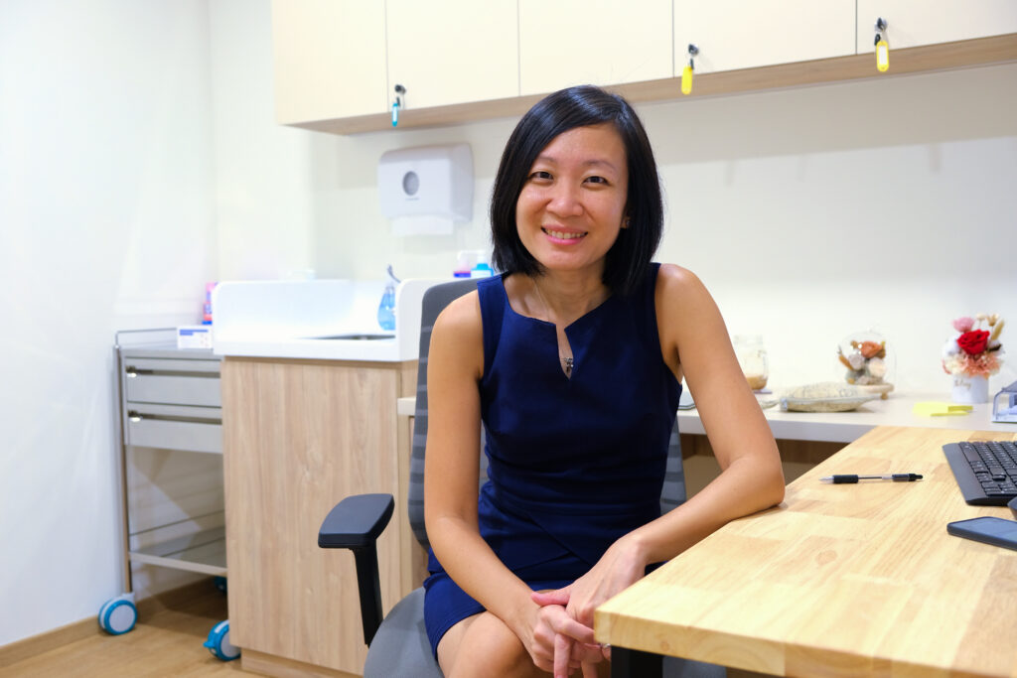

Dr Chen

|  |  |
| --- | --- |
|  | Enter clinic |
|  | Give name and IC number |
|  | Sit and wait |
| Dr Chen | See doctor |

VISITING THE DOCTOR

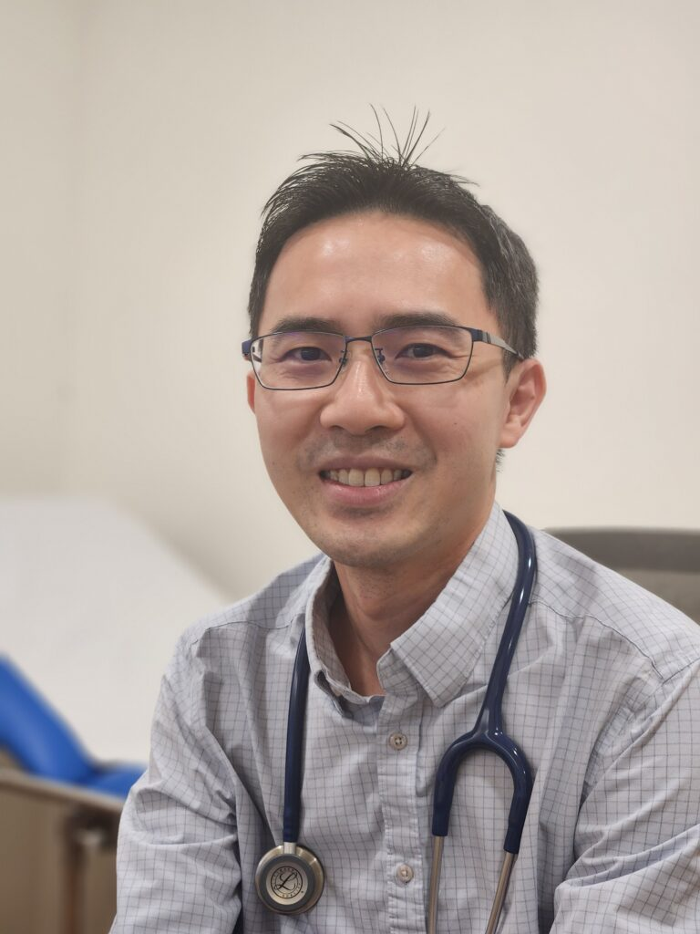

Dr See

|  |  |
| --- | --- |
|  | Enter clinic |
|  | Give name and IC number |
|  | Sit and wait |
| Dr See | See doctor |

# BLOOD PRESSURE

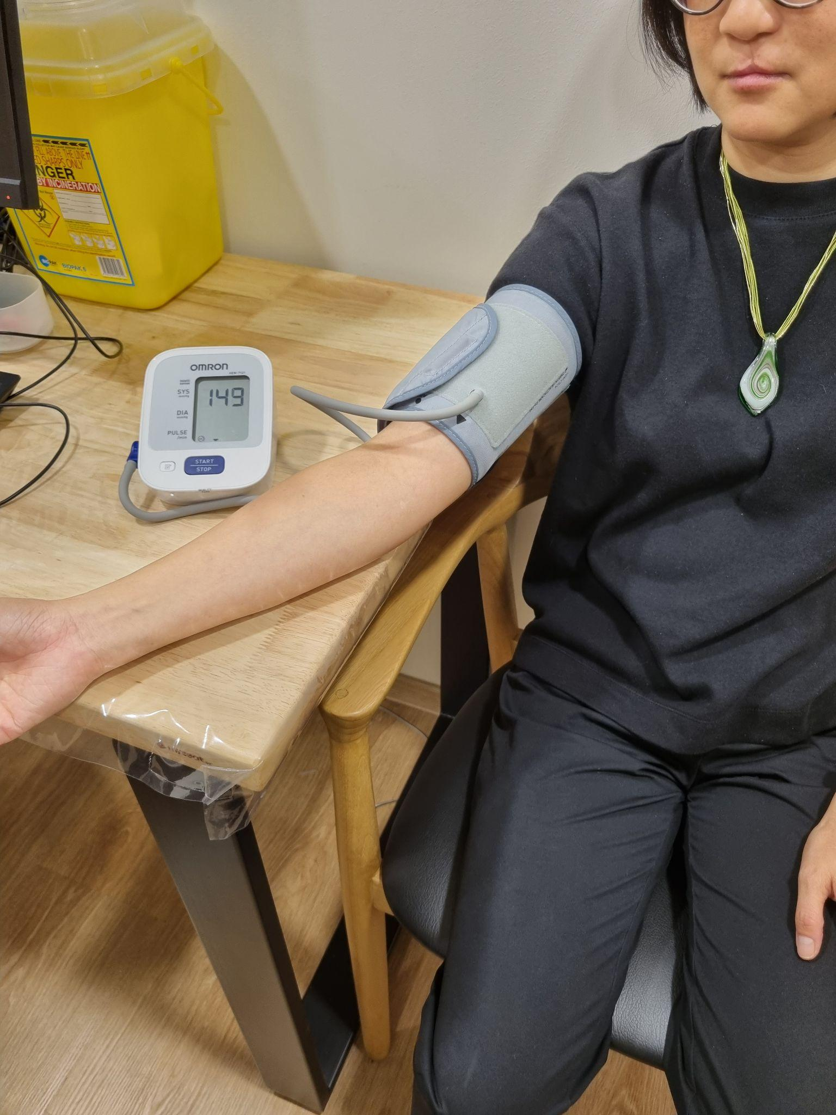

|  |  |
| --- | --- |
|  | Sit |
|  | Put cuff around arm |
|  | Press start |
|  | Wait |
|  | Tight |
|  | Take off cuff |

# CHECKING HYPOCOUNT

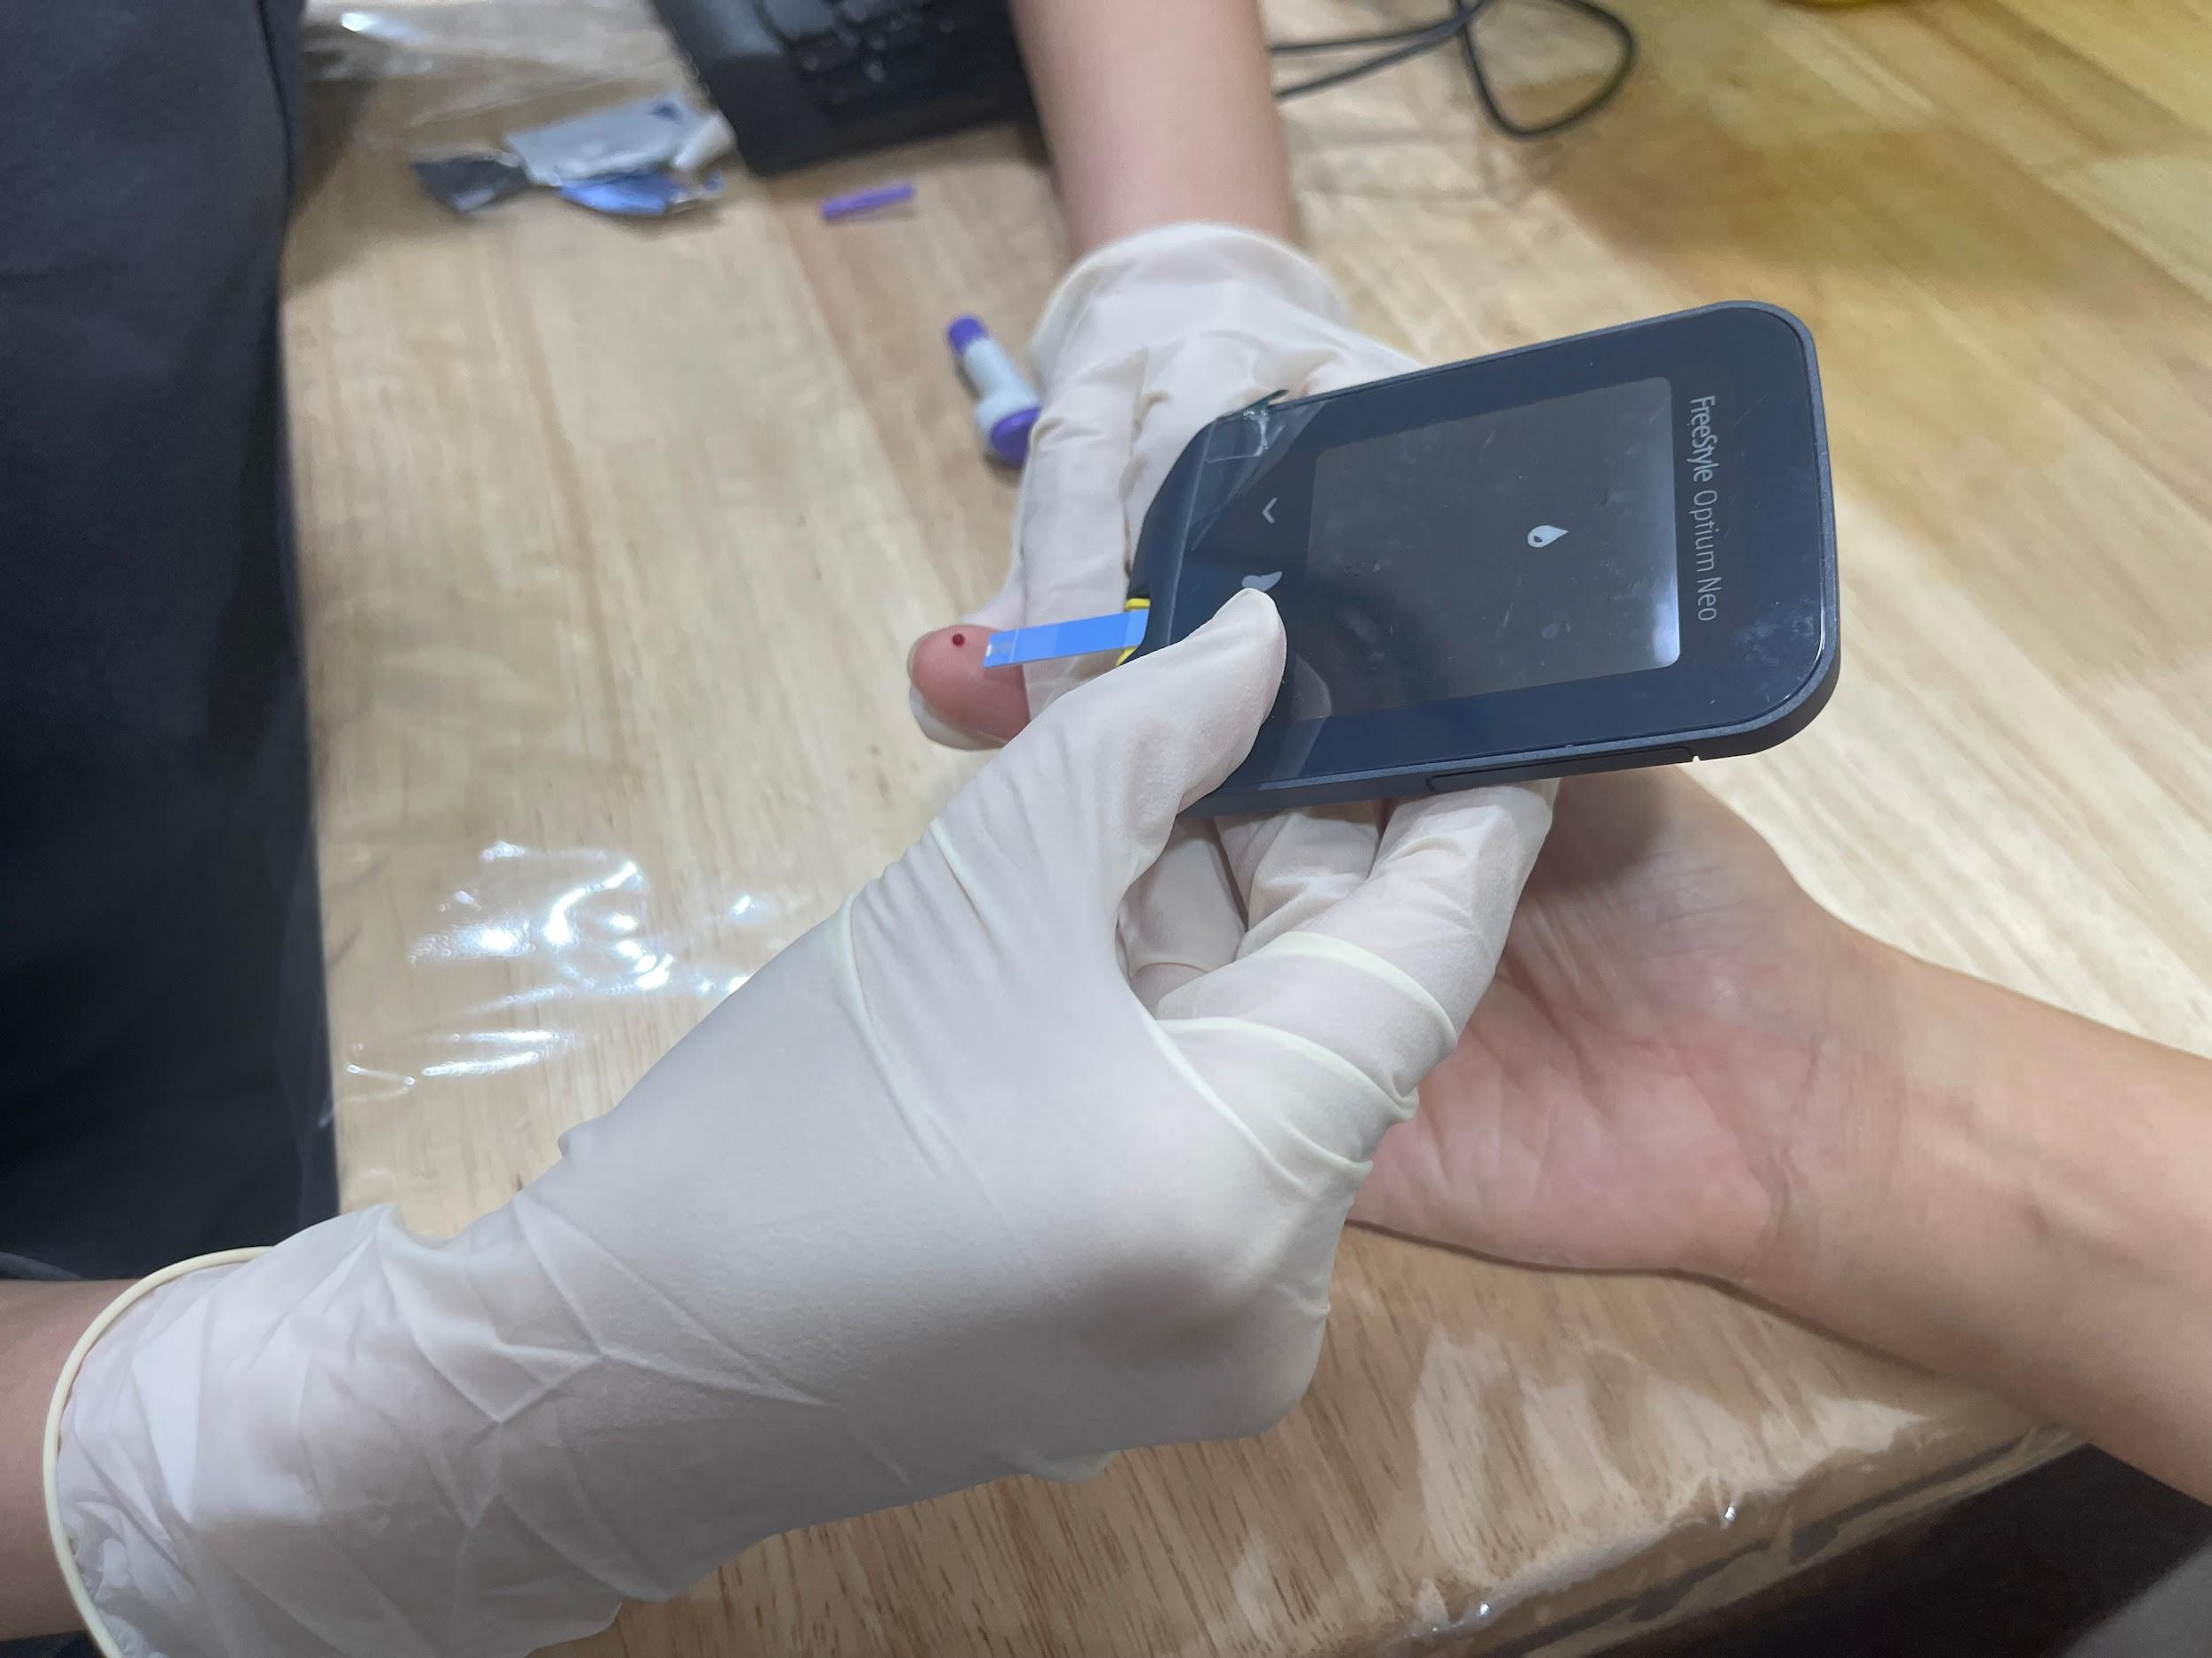

|  |  |
| --- | --- |
|  | Sit |
|  | Clean Finger |

|  |  |  |
| --- | --- | --- |
|  | | Nurse will use a small needle to prick finger |
| Ask patient if they are okay to continue | | |
| Yes | C:\Users\amanda_chan\Downloads\no.png  No | |
|  | | Prick finger |
|  | | Squeeze Finger |
|  | | Put blood |

# PHYSICAL EXAMINATION

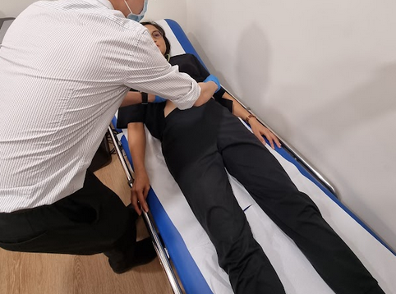

|  | Lie down on couch |
| --- | --- |
|  | Doctor will lift up your shirt |
|  | Doctor will touch you |
|  | Check stomach |

# AUSCULTATION

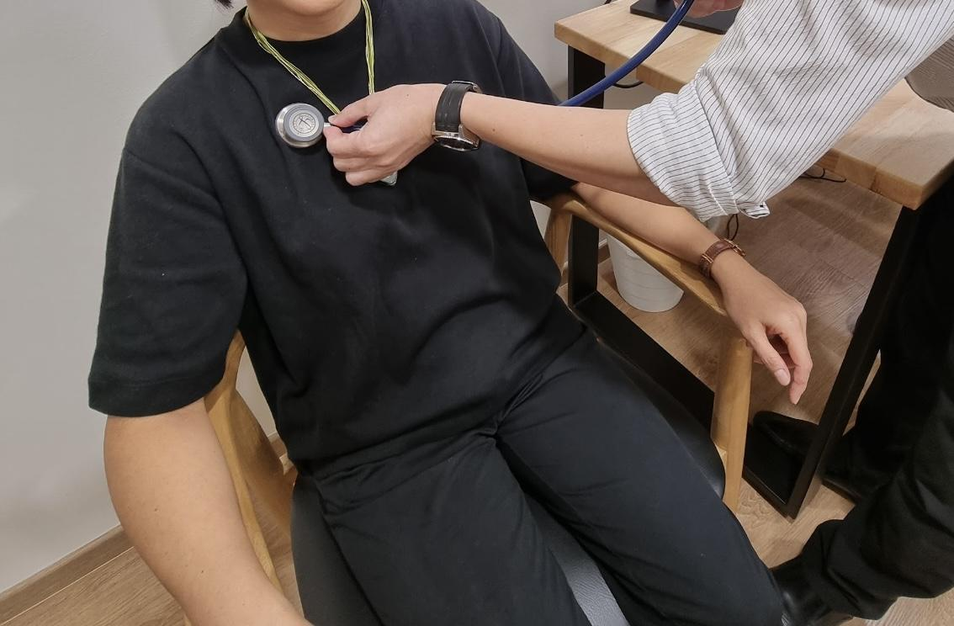

|  |  |
| --- | --- |
|  | Sit |
|  | Check chest |
|  | Breathe in Breathe Out |
|  | Check back |
|  | Breathe in Breathe Out |

# VACCINATION

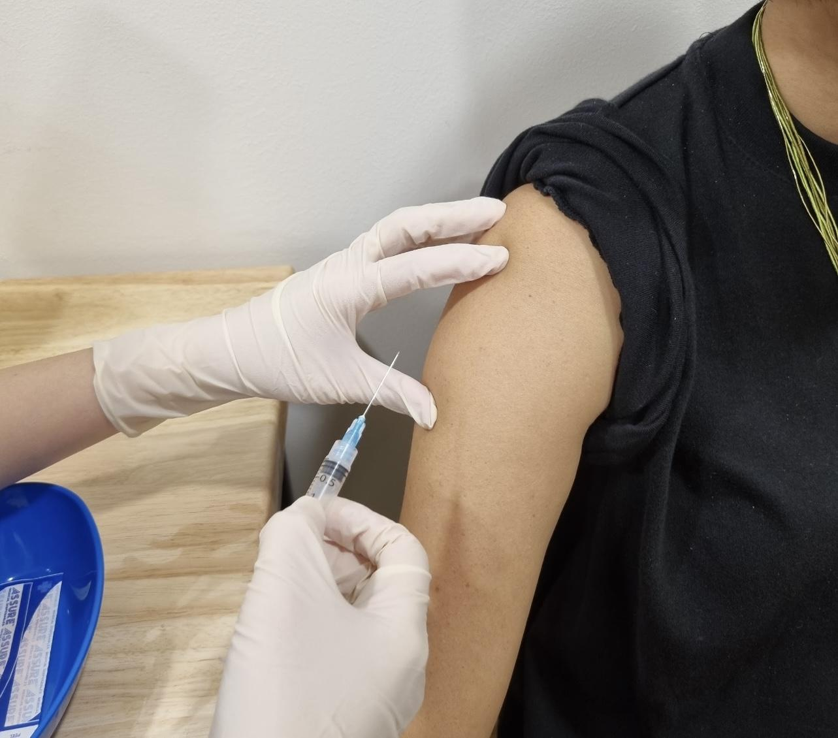

|  |  |  |
| --- | --- | --- |
|  | | Sit |
|  | | Roll up sleeve |
|  | | Clean arm |
|  | | Nurse will  give injection |
| Ask patient if they are okay to continue | | |
| Yes | C:\Users\amanda_chan\Downloads\no.png  No | |
|  | | Vaccine  injection |
|  | | Hold cotton |
|  | | Put plaster |

# BLOOD TEST

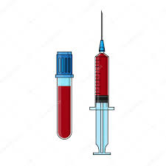

|  |  |  |
| --- | --- | --- |
|  | | Sit |
|  | | Roll up sleeve |
|  | | Arm out |
|  | | Tie tight |
|  | | Squeeze hand |
|  | | Find vein |
|  | | Clean skin |
| Wait Card - Autism Circuit | | Stay still  Don’t move |
| Ask patient if they are okay to continue | | |
| Yes | C:\Users\amanda_chan\Downloads\no.png  No | |
|  | | Breathe |
|  | | Put needle |
|  | | Take blood |
|  | | Relax hand |

|  |  |
| --- | --- |
|  | Press cotton  5 minutes |
|  | Put plaster |
|  | Finish |

# URINE SAMPLE

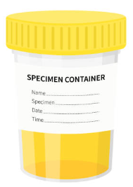

(Male)

Images from <https://www.nursingtimes.net/clinical-archive/assessment-skills/specimen-collection-1-general-principles-and-procedure-for-obtaining-a-midstream-urine-specimen-12-06-2017/> and <https://www.researchgate.net/profile/Robert-Eley/publication/295083317/figure/fig1/AS:334580440682496@1456781601699/llustration-of-midstream-urine-collection-technique.png>

|  |  |
| --- | --- |
|  | Open bottle |
|  | Pass some urine in toilet |
|  | Pass urine in bottle |
|  | Close bottle |
|  | Give bottle  to nurse |

URINE SAMPLE



(Female)

Images from <https://www.researchgate.net/profile/Robert-Eley/publication/295083317/figure/fig1/AS:334580440682496@1456781601699/llustration-of-midstream-urine-collection-technique.png>

|  |  |
| --- | --- |
|  | Open bottle |
|  | Pass some urine in toilet |
|  | Pass urine in bottle |
|  | Close bottle |
|  | Give bottle  to nurse |